MIMO Cube Formed of Slot Dipoles
Ákos Németh, László Szücs, Lajos Nagy
Budapest University of Technology and Economics,
Department of Broadband Infocommunications and Electromagnetic Theory,
H-1111 Budapest, Goldmann György tér 3, Hungary,
Email: nagy@mht.bme.hu
Abstract—This paper provides experimental and implementation details for various forms of multiple-input multiple-output (MIMO) cube antennas. Slot dipole antennas are used as basic elements of these MIMO antennas. Experimental results show that especially at higher frequencies of various wireless applications the additional loss of the printed antennas increase and therefore implementation of such antennas not always possible above 1-2 GHz. The suggested type of basic antenna elements provide almost lossless realization on cheap metallic plate. The two prototype are simulated, optimized and measured for 4.5-4.6 GHz. Coupling between dipoles are also measured and presented. The cube antennas exhibit an impedance bandwidth (VSWR ≤ 2) of 18% and 7%.
Results of simulations show that the theoretical capacity due to mutual coupling between MIMO antennas is lower than for implemented antennas with mutual coupling for cube side lengths less than about 0.3 λ. For the prototype antenna the S-parameter isolation between ports below -35 dB over a bandwith of 300 MHz and therefore excellent MIMO antenna can be formed without capacity degradation.

Index Terms—MIMO antenna, slot dipole, antenna measurement

INTRODUCTION
The multi-input multi-output (MIMO) array antenna can give recently a promise in increasing the capacity of wireless radio systems such as broadband wireless access systems, wireless local area networks (WLAN), third-generation (3G) networks and beyond. The MIMO cube as a compact antenna is one of a possible realisation but especially for higher frequencies the loss and coupling between the dipoles decreases the capacity of the system.
The slot dipole is promising a cheap and lossless solution for MIMO cube and this was investigated also in form of simulations and measurements.
MIMO antenna systems increase the capacity and performance of a conventional wireless system without the need for additional radiated power or spectrum. One challenge in these applications is the design of compact multiple antennas in small volume. One possible compact structure is the MIMO cube presented in [1-2] and system simulation are provided for ideal dipoles. Only few experimental and implementation results for the MIMO cube is found in the literature [3]. These antennas are implemented on printed board but the operation frequency is around 1 GHz. Applying the printed antenna structure especially for higher frequency applications expensive microwave PCB substrate has to be used.
The authors of [4] reported study on the effect of mutual coupling. In [5] the effect of mutual coupling has been shown to reduce capacity substantially especially when packing higher number of receiving antennas for a fixed aperture. Based on this published effect the mutual coupling minimization was one of our most important goal at the MIMO antenna design.
The slot antenna was finally choosen for implementation because of the two reasons above: the low material and manufacturing cost and the mutual coupling minimization. In this paper, a MIMO cube prototype consisting of three slot type dipole antennas is fabricated and tested accordingly.

The slot dipole
Wire dipole and a slot are complementary antennas. The solution for the slot can be found from the solution to an equivalent dipole by an interchange of the electric and magnetic fields. Not only the pattern but also the input impedance can be found.
Fig. 1. Dipole and folded dipole as complementary structures
Fig. 1. shows two such complementary structures. Babinet’s principle of optical screens extended by Booker to vector electromagnetic fields. If we take two such complementary screens and perform line integrals over identical paths to compute the impedance of each, we obtain the result for the input impedances

$Z_{1}⋅Z_{c}=\frac{η^{2}}{2}$ (1)

where Z1 is the input impedance of the structure, Zc the input impedance of the complementary structure, and η the impedance of free space (120π).
Both the structure and its complementary one radiate the same pattern but differ in polarization.
Using the (1) the folded slot dipole was choosen to the basic dipole element of the MIMO antenna because of its well matched impedance to 50 ohm coaxial transmission line without necessity of using any matching circuit.
As the first step the simulation and optimisation of the simple folded slot dipole over plane conductor. The theoretical electrical vector field distribution and the simulated one can be seen in Fig. 2.

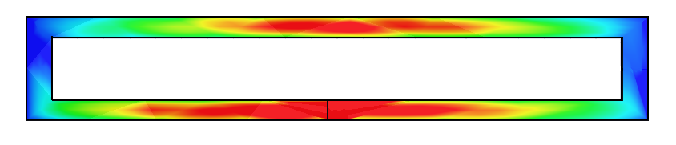
Fig. 2. Electrical field strength on the slot, theoretical and simulated

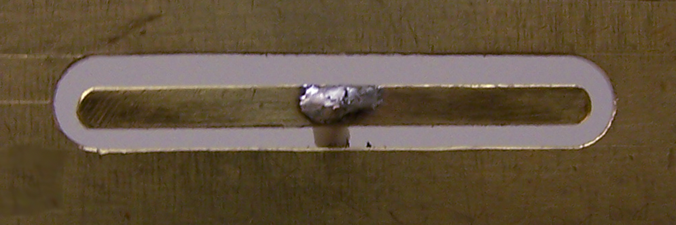

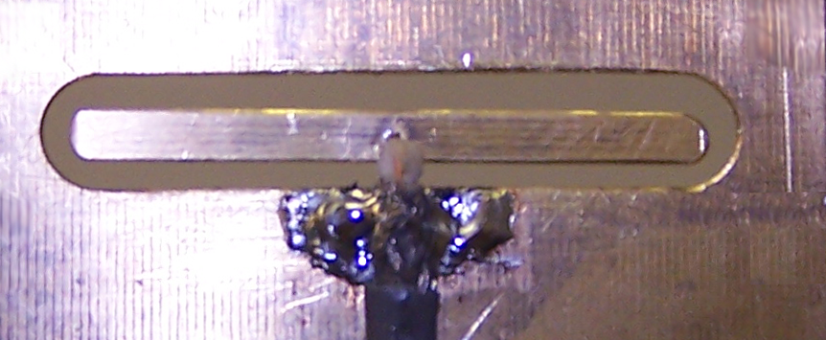
Fig. 3. Folded slot forward and backward side
The antennas are realized on copper plate with a thickness of 0.5 mm, the excitation is through 50 ohm coacial cables.
Fig. 4. Measured input reflection of slot dipole over plane conductor

Realized structures
Two MIMO antenna has been analized and realized for the comparison and optimization of especially the mutual coupling between the antenna elements.
The first structure realized prototype is a part of a MIMO cube with slot dipole on the edges (Fig. 4.)
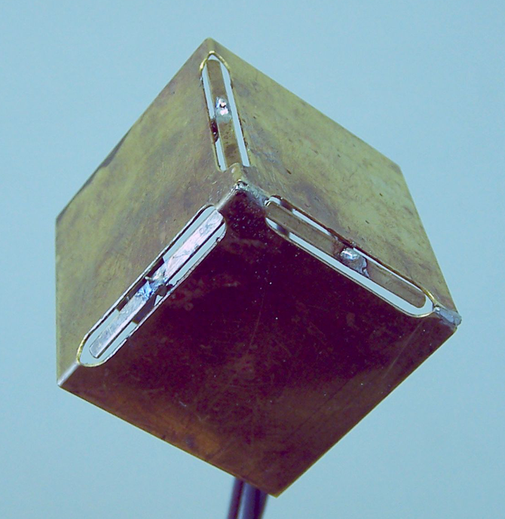
Fig. 4. MIMO cube with slot dipoles on edges

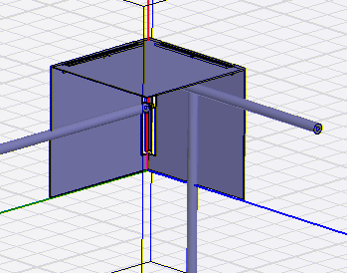
Fig. 5. HFSS model with excitation coaxial lines

The simulation has been performed using Ansoft HFSS on an Intel Xeon Duo bi-processor 3 GHz with 4 GB RAM memory. Simulation times for the analized structures for the 3-6 GHz frequency range are typically around 50-60 minutes.
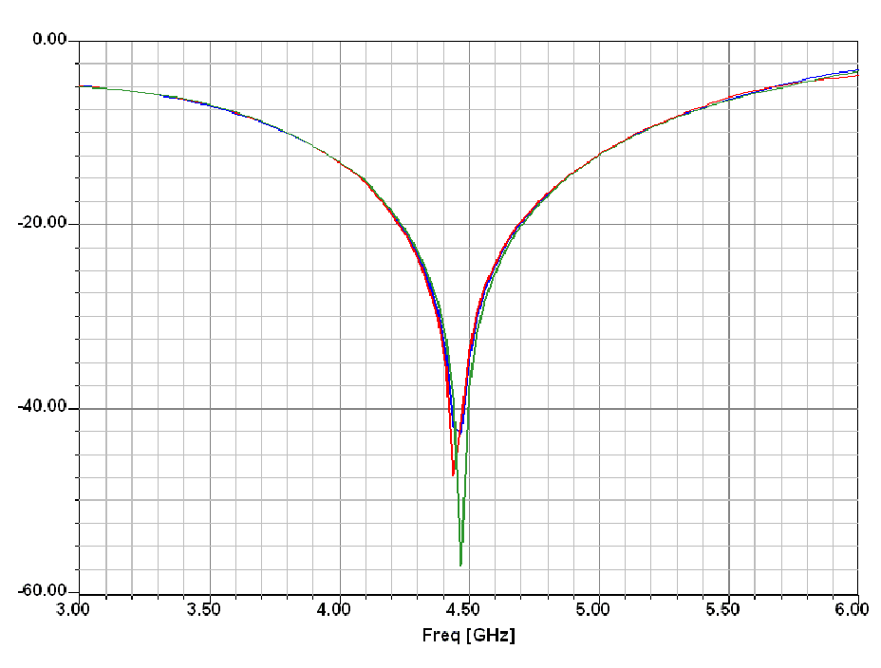
Fig. 6. Slot dipoles input reflection simulated results (S11, S22, S33 in dB)

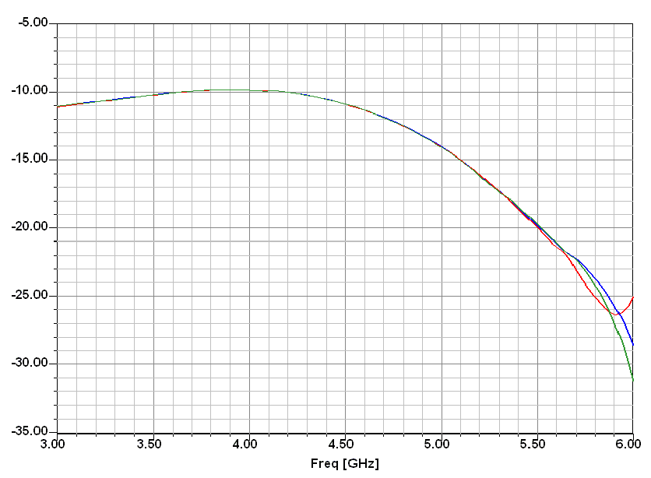
Fig. 7. Coupling between the slot dipoles simulated results (S12, S13, S23 in dB)
The simulations in Fig. 5. shows an excellent input reflection giving 30% of impedance bandwith (VSWR ≤ 2) but the mutual coupling between the dipoles are only below -10 dB and causing the MIMO capacity degradation.
The detailed analysis indicates surface currents flows on the board and giving an isolation decrease. Our second structure applies therefore separated boards for decreasing the coupling.

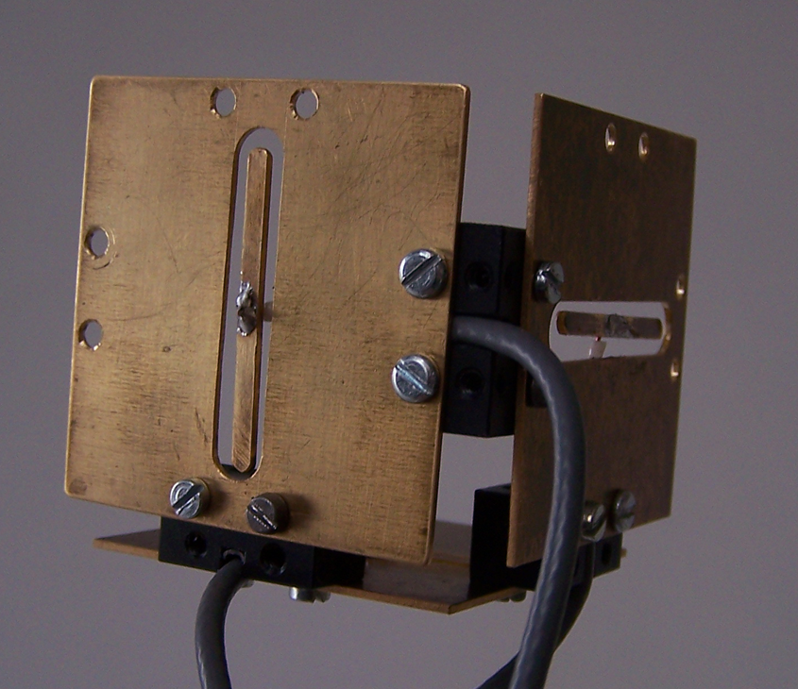
Fig. 7. MIMO cube with slot dipoles on separated planes

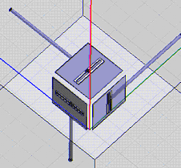
Fig. 8. HFSS model with excitation coaxial lines

The main dimensions of the realized MIMO antenna are:
• Slot with: 6mm
• Slot length: 34mm
• Middle section with: 2,5mm
• Middle section length: 32mm

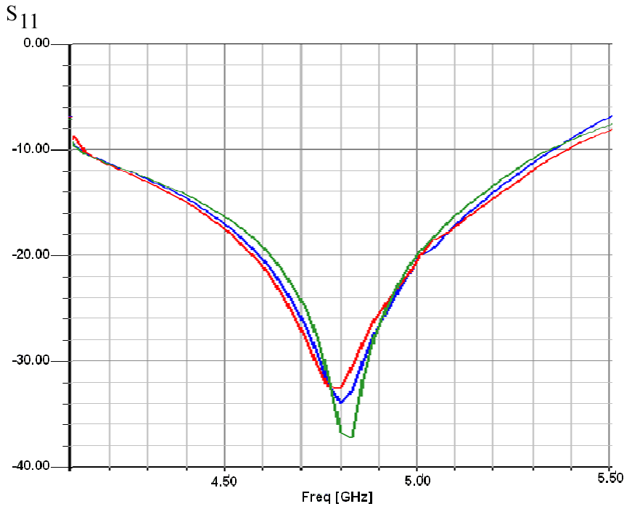
Fig. 9. Slot dipoles input reflection (S11, S22, S33)

Results

Measurement of input reflection coefficients and coupling are shown in Fig. 10-14. measured with S-parameter Vector Network Analyzer HP 8753 ES (30 kHz-6 GHz))

MIMO cube with slot dipole on the edges

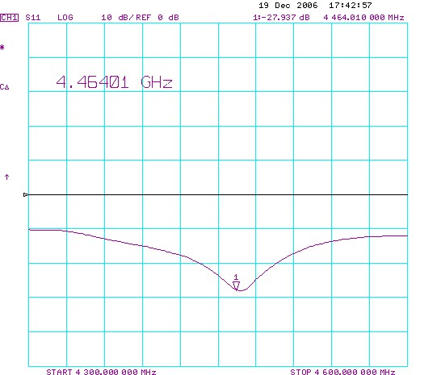

Fig. 10. Slot dipoles measured input reflection (S11 in dB)

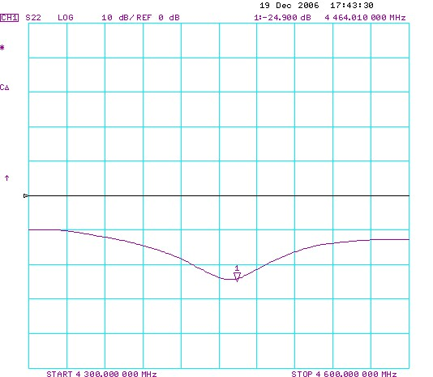
Fig. 11. Slot dipoles measured input reflection (S22 in dB)

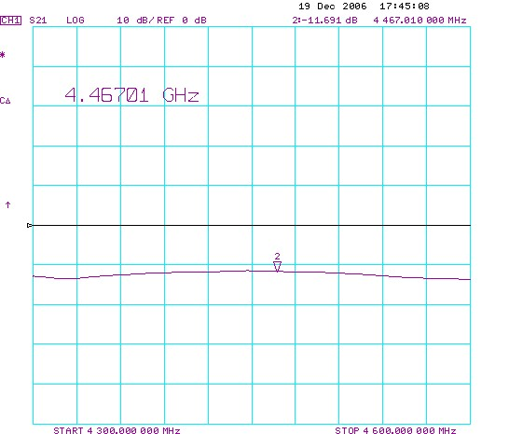
Fig. 12. Slot dipoles measured coupling (S21 in dB)

The measured results presented in Fig. 10. and 11. show an excellent input reflection giving 30% of impedance bandwith (VSWR ≤ 2) as by the simulations. The mutual coupling between the dipoles are slightly below -10 dB which would be much this level below for MIMO application without capacity degradation.

MIMO cube with slot dipoles on separated planes

The MIMO cube built up from slot dipoles on separated planes are also measured and the results are in Fig. 13. presented.

Fig. 13. Measured MIMO antenna input reflection and coupling (S11 and S21 in dB) for dipoles on separated planes

For the second prototype antenna the also the input reflection and also the S-parameter isolation between ports guarantied a MIMO applicability without capacity degradation.

Conclusion

This paper has provided proposed type of MIMO antenna and measurement results for two prototyped MIMO cube. We have found that for the second MIMO antenna the S-parameter isolation between ports below -35 dB over a bandwith of 300 MHz.
Acknowledgment
This work was carried out in the framework of Mobile Innovation Center, Hungary (Mobil Innovációs Központ).
References
- B. N. Getu and J. B. Andersen, “The MIMO cube – A compact MIMO antenna,” IEEE Trans. Wireless Commun., vol. 4, no. 3, pp. 1136-1141, May 2005.
- B. N. Getu and R. Janaswamy, “The effect of mutual coupling on the capacity of the MIMO cube,” IEEE Antennas Wireless Propagat. Lett., vol. 4, pp. 240-244, 2005.
- Chi Yuk, Chiu, Ross D. Murch: Experimental Results for a MIMO Cube, Antennas and Propagation Society International Symposium 2006, IEEE, 9-14 July 2006 Page(s):2533 - 2536
- T. Svantesson and A. Ranheim, “Mutual coupling effects on the capacity of multielement antenna systems,” in Proc. IEEE Int. Conf. Acoustics,Speech and Signal Processing, vol. 4, Salt Lake City, UT, May 2001, pp. 2485–2488.
- R. Janaswamy, “Effect of element mutual coupling on the capacity of fixed length linear arrays,” IEEE Antennas Wireless Propag. Lett., vol. 1, pp. 157–160, 2002.

 

